**Assessment Task 1: Written Questions**

1. **Explain the following five important principles of modern accounting, with relevant examples, in no more than 100 words each.**
2. **The Revenue Principle**

This is a concept in the accrual basis of accounting where any revenue that the company earns should be recorded and recognized at the point of sale. In other words, companies shouldn’t wait until revenue is actually collected to record it in their books.

For example, A Retail sells clothing from its retail outlet. A customer purchased a shirt on June 15th and pays for it on a credit card. A Retail processes the credit card but does not actually receive the cash until July. The revenue should have recorded in June when it’s realized.

1. **The Expense Principle**

Expenses should be recorded in books the moment they’re incurred. The moment you accept any goods or services from another entity. The principle doesn’t take into account when and how the billing takes place.

[expenses](https://www.accountingtools.com/articles/2017/5/6/expense) should be [recognized](https://www.accountingtools.com/articles/2017/5/11/recognition) in the same period as the [revenues](https://www.accountingtools.com/articles/2017/5/11/revenue) to which they relate. If this were not the case, expenses would likely be recognized as incurred, which might predate or follow the period in which the related amount of revenue is recognized.

For example, a business pays $100,000 for [merchandise](https://www.accountingtools.com/articles/2017/5/8/merchandise-inventory), which it sells in the following month for $150,000. Under the expense recognition principle, the $100,000 cost should not be recognized as expense until the following month, when the related revenue is also recognized. Otherwise, expenses will be overstated by $100,000 in the current month, and understated by $100,000 in the following month.

1. **The Matching Principle**

The matching principle helps you match and balance out your revenues and expenses. The underlying theory is that every time you sell a product, you must have incurred some sort of expense to make it happen. This includes selling expenses, manufacturing expenses, and administrative expenses.

As per the matching principle, every time you record some sort of revenue, you should also match it up for an item of revenue. For instance, if you’ve sold one taco and record the sale on your QuickBooks account. To match it up, you should also simultaneously record entries for the expenses that you incurred to buy the taco shells, meat, toppings, and other ingredients.

If the two entries are recorded at different time periods separately, it could lead to discrepancies and inconsistencies within your accounting data.

1. **The Cost Principle**

The cost principle is one of the basic underlying guidelines in accounting. It is also known as the historical cost principle. According to the cost principle, whenever you’re recording the cost of any item, always use the historical cost and not the resell cost. The cost principle requires that assets be recorded at the cash amount (or the equivalent) at the time that an asset is acquired.

For example, there is a real-estate business that buys and sells land and property. Every time it sells some property, record the historical cost and not the one that’s currently trading in the fair market.

1. **The Objectivity Principle**

The objectivity principle states that accounting information and financial reporting should be independent and supported with unbiased evidence. This means that accounting information must be based on research and facts, not merely a preparer’s opinion. The objectivity principle is aimed at making financial statements more relevant and reliable.

The concept of relevance implies that financial statements can have predictive value and feedback value. This means the financial statements are accurate and can be used to predict future company performance.

For example, Nancy is an accountant in charge of preparing financial statements for Big Ben, Inc. Nancy asks for Big Ben’s records to support its payables and receivables, but Big Ben says it will be too much work to get. Big Ben says to go with the numbers in the accounting system. This is a violation of the objectivity principle because the financial statements must be based on verifiable and reliable records– not someone’s opinion.

1. **Describe the three financial statements and at least 3 key features of each. Explain how they are all linked and dependent on each other. Respond in no more than 750 words.**

The balance sheet, income statement, and cash flow statement each offer unique details with information that is all interconnected. Together the three statements give a comprehensive portrayal of the company’s operating activities.

The Balance Sheet:

A Balance Sheet refers to the position statement, which lists out the balances of the assets, liabilities and owner’s equity of a company at a specific date.

* The preparation of Balance Sheet is not for a period, but at a particular date.
* The preparation of the balance sheet is possible only when profit and loss account for the period is prepared because it reflects the financial position of the company adequately. That is why the Profit & Loss Account, Balance Sheet and [Cash flow Statement](https://businessjargons.com/cash-flow-statement.html) are collectively called as Final Accounts.
* The totals of the two sides, i.e. assets and liabilities of the balance sheet must tally as **Assets = Liabilities + Capital**. If not so, then there must be an error.

The Income Statement:

The income statement, or profit and loss statement (P&L), reports a company’s revenue, expenses, and net income over a period of time.

* The income statement, or profit and loss statement (P&L), reports a company’s revenue, expenses, and net income over a period of time.
* Depending on the method of accounting, revenues don’t always mean that cash must be received. Alternatively, just because cash is received doesn't mean revenue is recognized.
* Expenses are what a firm pay during a specific period of time in order to generate those revenues.

The Cash Flow Statement:

A cash flow statement is a statement of changes in the financial position of a firm on cash basis. It reveals the net effects of all business transactions of a firm during a period on cash and explains the reasons of changes in cash position between two balance sheet dates.

* It is a periodical statement as it covers a particular period.
* This statement does not recognize matching principles.
* It exhibits the changes of financial positions relating to operational activities, investing activities and financial activities, respectively, by which an analyst can draw his conclusion.

1. **In the context of an organisation’s internal communication needs, (a) explain what written and verbal communication entail and when each is most effective (b) state 5 principles an organisation should follow when communicating information to employees (c) state 3 effects of poor organisational communication with suitable examples. Respond in no more than 500 words.**
2. Effective verbal communication skills include more than just talking. Verbal communication encompasses both how you deliver messages and how you receive them. Verbal communication is easier to have, it saves time, it is more effective as emotions are well portrayed, the feedback loop is faster, verbal communication is economical, and the tone is easy to read.

Written Communication is more effective when:

* Conveying complex information
* There is a need for permanent record
* The audience are large in number and geographically dispersed
* There is a less need for interaction with audience

1. There are 5 principles for employee communications:

* Make content both relevant and high quality
* Sensitive to employee time and attention, be respectful to the employees
* employees should be exposed to relatable communication that tells them what they need to do
* Using modern content management system to enable more authentic voices in the employee communication
* Be able to recognize good, creative communication design

1. Poor Communication would affect a business in the following aspects:

* Increased employee turnover

Employee retention is a huge metric because it is not only costly but also impacts the company’s ability to serve its customers. Research estimates that replacing an employee can cost as much as 3x the person’s salary. On the flip side, when companies do communicate effectively, they are 50 percent more likely to report turnover levels below the industry average.

* Lower employee productivity

With poor communication in the workplace comes lower productivity because employees don’t have access to the people, knowledge, and resources that help them do their jobs and don’t have the passion and motivation to perform well or even exceed expectations.

* Poor customer service

If employees don’t have the information they need to do quality work, it can be quite detrimental for customer-facing roles, and low employee morale is felt by customers during their interactions and creates a negative experience.

1. **Answer the following in the context of financial reporting compliance requirements of a public-listed organization with an annual GST turnover of $19.5m.**

a)

|  |  |
| --- | --- |
| Document | Section of the Corporate Act |
| 1.Directors' report, including the auditor's independence declaration | 298-300A |
| 2.Auditor’s report | 301&308 |
| 3. Directors' declaration that the financial statements comply with accounting standards, give a true and fair view, there are reasonable grounds to believe the company/scheme/entity will be able to pay its debts, the financial statements have been made in accordance with the Corporations Act | 295(4) |
| 4. Statement of profit or loss and other comprehensive income for the year (consolidated, if required by accounting standards) | 295(2) &296(1) |
| 5. Consolidated financial statements required by accounting standards may include parent entity financial statements where Class Order [[CO 10/654]](https://www.legislation.gov.au/Details/F2017C00172) *Inclusion of parent entity financial statements in financial reports*conditions are met. | 295(2) & 296 (1) |

1. **What is the organisation’s ATO-mandated GST reporting and payment cycle?**

The GST reporting and payment cycle will be one of the following:

* Monthly – if your GST turnover is $20 million or more.
* Quarterly – if your GST turnover is less than $20 million – and we have not told you that you must report monthly.
* Annually – if you are voluntarily registered for GST. That is, you are registered for GST; and your GST turnover is under $75,000 ($150,000 for not-for-profit bodies).

1. **How can the organisation remain compliant when its annual GST turnover exceeds $20 million?**

The ATO regulates that an organization can change the cycle it uses to report and pay GST depending on the circumstances.  This may happen when the GST turnover changes or if you choose to report and pay using a different cycle.

If the annual GST turnover exceeds $20m, the organization should report and pay its GST monthly.

1. **Answer the following questions:**
2. **In the context of financing a business, define the cost of capital and explain how it is a crucial variable in determining the company’s capital structure. Respond in no more than 100 words.**

Cost of capital is the minimum [rate of return](https://corporatefinanceinstitute.com/resources/knowledge/finance/internal-rate-return-irr/) that a business must earn before generating value. It’s an opportunity cost of investing the same amount of cash into different investment opportunities, with the real cost of capital the amount of money that could have been earned by choosing one investment over the other.

This consists of both the cost of debt and the cost of equity used for financing a business. A company’s cost of capital depends, to a large extent, on the type of financing the company chooses to rely on – its capital structure.

Cost of capital is an important factor in determining the company’s capital structure. Determining a company’s optimal [capital structure](https://corporatefinanceinstitute.com/resources/knowledge/finance/capital-structure-overview/) can be a tricky endeavor because both debt financing and equity financing carry respective advantages and disadvantages. It is vital in designing the optimal capital structure of the firm, wherein the firm's value is maximum, and the cost of capital is minimum. It can also be used to appraise the performance of specific projects by comparing the performance against the cost of capital.

1. **In the context of investing in a business, investor A wants to invest in Company X. A sees that the Weighted Average Cost of Capital of Company X is 10% and the return on capital at the end of the period is 9%. Should investor A invest in the business? Why or why not?**

It’s not recommended on A to invest in Company X. Company X yields returns of 9% and has a WACC of 10%, and this means the company is losing 1 cent for every dollar spent, indicating that potential investors would be best off putting their money elsewhere.

1. **What is working capital and how is it different from using a company’s capital for longer-term investments in fixed assets or R&D? Respond in no more than 150 words.**

Working capital is the difference between a company’s current assets and its current liabilities. is a measure of a company's liquidity, operational efficiency and its short-term financial health. It refers to the difference between operating current assets and operating current liabilities.

Fixed capital is defined as the part of the total capital of the enterprise which is invested in long-term assets. Working Capital refers to the capital, which is used to perform day to day business operations. Fixed capital investments include durable goods, which will remain in the business for more than one accounting period. On the other hand, Working capital comprises of short-term assets and liabilities of the business.

And fixed capital is used to buy non-current assets and is relatively illiquid because it cannot be converted into cash easily while working capital is used for short-term financing and are readily converted into cash.

1. **In the context of a finance manager’s role in making corporate decisions, identify and classify the following activities as related to either financing or investment decisions. One has been done for you as an example.**

|  |  |
| --- | --- |
| **Activity** | **Financing/Investment Decision** |
| 1. Analysing whether the resources adapt to the optimal size desired for the company. | **Investment** |
| 1. Deciding the company’s “financing mix”. | **Financing** |
| 1. Defining the optimal size of the company. | **Financing** |
| 1. Defining the types of assets that the company must acquire, or otherwise sell or get rid of, in order to achieve efficient management. | **investment** |
| 1. Ensuring continuity of the business over the long term. | **Investing** |
| 1. Maintaining a constant inflow of capital. | **investing** |
| 1. Studying the sources willing to offer credit to the organisation and define the best financing options for operations. | **Financing** |

1. Financial management deals with the management of all the financial resources of an organisation to help achieve the organisational goals. In this context, explain:
2. the goal of profit maximisation

Profit maximization refers to maximizing dollar income of the firm. It is considered as a principle objective of a firm because price and output decision associated with a firm is usually based on the profit maximization criteria. According to this goal, the actions that increase profits should be undertaken and those that decrease profits are to be avoided.

1. the goal of shareholder wealth maximization

The shareholder wealth maximization goal states that management should seek to maximize the present value of the expected future returns to the owners (that is, shareholders) of the firm. Shareholder wealth is measured by the market value of the shareholders' common stock holdings.

When business managers try to maximize the wealth of their firm, they are actually trying to increase the company's stock price. As the stock price increases, the value of the firm increases, as well as the shareholders' wealth.

1. at least 3 fundamental differences between the two goals

* risk management

Under profit maximization, management minimizes expenditures, so it is less likely to pay for [hedges](https://www.accountingtools.com/articles/2017/5/10/hedge) that could reduce the organization's risk profile. A wealth-focused company would work on risk mitigation, so its risk of [loss](https://www.accountingtools.com/articles/2017/5/13/loss) is reduced.

* [Pricing strategy](https://www.accountingtools.com/articles/2017/5/16/pricing-strategies)

When management wants to maximize profits, it prices products as high as possible in order to increase margins. A wealth-oriented company could do the reverse, electing to reduce prices in order to build [market share](https://www.accountingtools.com/articles/2018/6/10/market-share) over the long term.

* Planning duration

Under profit maximization, the immediate increase of profits is paramount, so management may elect not to pay for [discretionary expenses](https://www.accountingtools.com/articles/what-is-a-discretionary-cost.html), such as advertising, research, and maintenance. Under wealth maximization, management always pays for these discretionary [expenditures](https://www.accountingtools.com/articles/2017/5/6/expenditure).

1. **Briefly explain the following three principles of finance in relation to an organisation’s operations:**
2. **Principles of risk and return, and their correlation**

The risk-return tradeoff states that the potential return rises with an increase in risk. Using this principle, individuals associate low levels of uncertainty with low potential returns, and high levels of uncertainty or risk with high potential returns. Investments with different levels of risk are often placed together in a portfolio to maximize returns while minimizing the possibility of [volatility](https://www.investopedia.com/terms/v/volatility.asp) and loss.

A positive correlation exists between risk and return: the greater the risk, the higher the potential for profit or loss. Therefore, an investor needs to understand his individual risk tolerance when constructing a portfolio.

1. **Time value of money**

It is the idea that money that is available at the present time is worth more than the same amount in the future, due to its potential earning capacity.

There are five variables regarding this concept:

* Present value (PV) - This is your current starting amount.  It is the money you have in your hand at the present time, your initial investment for your future.
* Future value (FV) - This is your ending amount at a point in time in the future. It should be worth more than the present value, provided it is earning interest and growing over time.
* The number of periods (N) - This is the timeline for your investment (or debts). It is usually measured in years, but it could be any scale of time such as quarterly, monthly, or even daily.
* Interest rate (I) - This is the growth rate of your money over the lifetime of the investment. It is stated in a percentage value, such as 8% or .08.
* Payment amount (PMT) - These are a series of equal, evenly-spaced cash flows.

1. **Cash flow principle**

* Be realistic

Forecasting isn’t about putting your best outcomes on the paper to feel good about it; it’s about discovering potential pitfalls.

* Plan multiple scenarios.

There are many unpredictable events in the future such as market crashes and changes of sentiment that will affect your bottom line. One way to deal with that is to create several versions of a forecast.

* Factor in fixed and variable costs

**Assessment Task 2**

**Part A-Written Report**

The Finance Policies and Procedures Manual of Apex Learning Institute provide the Financial Department and its employees with detailed guidelines to ensure the efficient management and control of all resources. It also ensures compliance with applicable laws, financial policies and regulations. In the Manual, effective controls on assets, liabilities, funds, expenditures and relevant systems have been identified. However, after reading the Manual in conjunction with other specific finance policies where relevant, to have an adequate system of internal control, it is recommended that the following three gaps are better to be considered:

* Financial reporting responsibilities
* Management systems for information management
* Financial risk management

In this report, we will draft policies and procedures of each of them in the following content, and also improve the current Budget Audit and Compliance procedures.

**Financial Reporting Policy**

Policy Number: 012

Policy Date: 15/06/2020

**Purpose of the Policy**

To provide a consistent reporting of financial information to stakeholders

**Procedures:**

Under general law and the Corporate Act 2001, the director has a duty of care and diligence. It’s necessary for a director to take reasonable steps to comply with, or secure comply with, the financial reporting and audit requirements of the Corporate Act, including the requirement to keep accurate and complete books and records.

Apex Learning Institute must keep written financial records that:

* correctly record and explain the company’s transactions and its financial position and performance
* enable true and fair financial statements to be prepared and audited.

It’s might be required to lodge financial reports with ASIC accompanying with the director’s declaration that:

* whether, in the directors’ opinion, there are reasonable grounds to believe that the company will be able to pay its debts as and when they become due
* whether the financial statements and notes comply with accounting standards, and give a true and fair view of the financial position and performance of the company and any consolidated entity

Besides, the director is required to read, understand and focus on the contents of the company’s financial report ensuring:

* the information included is accurate as far as possible and reasonable
* question the accounting treatments applied
* examine the adequacy of disclosures and whether any matters have not been disclosed that should be disclosed.

**Management Systems for information management**

Policy Number: 013

Policy Date: 15/06/2020

**Purpose of the Policy**

The policy is designed to guide and direct the creation and management of information, and to clarify staff responsibilities. Apex is committed to establishing and maintaining information management practices that meet its business needs, accountability requirements and stakeholder expectations.

**Procedures:**

Business information must be created and captured by everyone subject to this policy.

Business information created should provide a reliable and accurate account of business decisions and actions. Include all necessary information to support business needs, including names, dates and time, and other key information needed to capture the business context.

* the primary information management system is an e-learning and –management system. All incoming paper should be converted to digit format and be stored and backup on the e-platform
* business and administrative databases and software applications are endorsed for the capture and storage of specific information
* corporate information must not be maintained in email folders, shared folders, personal drives or external storage media as these lack the necessary functionality to protect business information over time.
* information is a corporate resource to which all staff may have access, except where the nature of the information requires restriction
* it is regulated under the Information Publication Scheme that we should provide access to publicly available information on our website

Financial Risk Management

Policy Number: 015

Policy Date: 16/06/2020

**Purpose of the Policy**

Apex recognizes a need to avoid unexpected losses, as far as possible, the risks associated with business activities. Financial management will be executed to limit circumstances that expose the Apex to risk from speculative activities.

**Procedures**

* It is the responsibility of the Office of Vice-Principal (Administration and Finance) to implement and maintain this policy and ensure its application. None of its units reporting into the VP (A&F) will engage in speculative use of derivatives.

In order to achieve these objectives, the respective groups under the VP (A&F) are responsible for:

* Determining the University’s risk position with respect to the risks and exposure;
* Working with subsidiaries and all units within the University to identify financial risks of the University;
* Ensuring that exposure to any counterparty is limited to amounts established under this policy as up-dated from time-to-time;
* Developing, and if deemed appropriate, implementing a hedging strategy.

**Improved Budget Audit and Compliance Policy**

Policy Number: 011

Policy Date: DD/MM/YYYY

**Purpose of the Policy**

This policy provides guidelines for reasonable assurance over the financial activities under direct control of and the financial governance and financial management of Apex Learning Institute.

**Procedures**

Apex Learning Institute must:

* Implement and maintain processes for the annual audit of its training and assessment systems, policies and procedures across all of its operations and scope of registration, for compliance against SRTOs
* follow Australian Skills Quality Authority (ASQA) policy and procedures ensuring that financial systems and controls are in place to enable contracted auditors to perform all the required field work and issue an audit opinion.
* Accept and cooperate fully with ‘external audits’ conducted by Auditors from the relevant VET Regulator or Funding body, providing accurate and truthful responses to information requests

The following steps describe the audit process undertaken by the appointed external auditors.

1. Determine the audit methodology which may include Apex Learning Institute completing a pre-audit questionnaire.
2. Agree with Apex Learning Institute on a suitable time for an audit visit to the school.
3. ​Conduct an opening meeting with the CEO and the finance manager.
4. Undertake the audit.
5. Conduct an exit meeting with the CEO to discuss the issues identified.
6. Draft an audit report and a management letter outlining issues identified and recommendations to address those issues.
7. Request that the CEO provide management responses to the management letter’s recommendations including:
   1. acceptance or non-acceptance of the audit recommendation
   2. action planned in response
   3. responsible officer
   4. planned completion date.
8. Finalise the audit report and management letter including the assignment of an overall audit rating based on the 'overall audit rating definitions' defined by ASQA.
9. Results of audits will:

* be documented on the Self-Assessment Tool and Audit Report;
* and ii. Include observations of compliances, non-compliances and opportunities for improvements (OFIs), as relevant.

If corrective actions or further investigation is required, these will be identified and implemented.

Outcomes of all audits feed into Continuous Improvement practices. (See Continuous Improvement Policy)

1. Forward the following completed audit documentation to the CEO:
   1. audit report
   2. financial statements upon which the audit opinion is made as attachments to the audit report. (The financial statements are prepared by Apex Learning Institute).
   3. management letter outlining areas for improvement.
2. Provide a copy of the final reports to ASQA.​

References:

<https://resources.smartbizloans.com/blog/business-finances/5-most-important-financial-policies-and-procedures-for-small-business/>

<https://sswm.info/sites/default/files/reference_attachments/finance%20policies.pdf>

<https://asic.gov.au/regulatory-resources/financial-reporting-and-audit/directors-and-financial-reporting/>

<https://www.naa.gov.au/information-management/information-governance/establishing-information-governance-framework/developing-information-management-policy>

**Part C**

**1.’Historical &Forecasts’ and ‘Financial Analysis’ worksheet**

**a. Calculation**

Return on Total Assets

Return on assets is a profitability ratio that provides how much profit a company is able to generate from its assets. It measures how efficient a company's management is in generating earnings from their economic resources or assets on their balance sheet.

ROA=Net Income/Average Total Cost

Cost of Borrowing

Cost of Borrowing. Cost of borrowing refers to the total amount a debtor pays to secure a loan and use funds, including financing costs, account maintenance, loan origination, and other loan-related expenses.

COB=Interest/Debt

Return on Equity

Return on equity (ROE) measures how effectively management is using a company’s assets to create profits.

ROE=Net Income/Shareholders’ Equity

Debt-equity Ratio

The ratio is used to evaluate [a company's financial leverage](https://www.investopedia.com/ask/answers/040915/what-considered-good-net-debttoequity-ratio.asp). The D/E ratio is an important metric used in corporate finance. It is a measure of the degree to which a company is financing its operations through debt versus wholly-owned funds. More specifically, it reflects the ability of shareholder equity to cover all outstanding debts in the event of a business downturn.

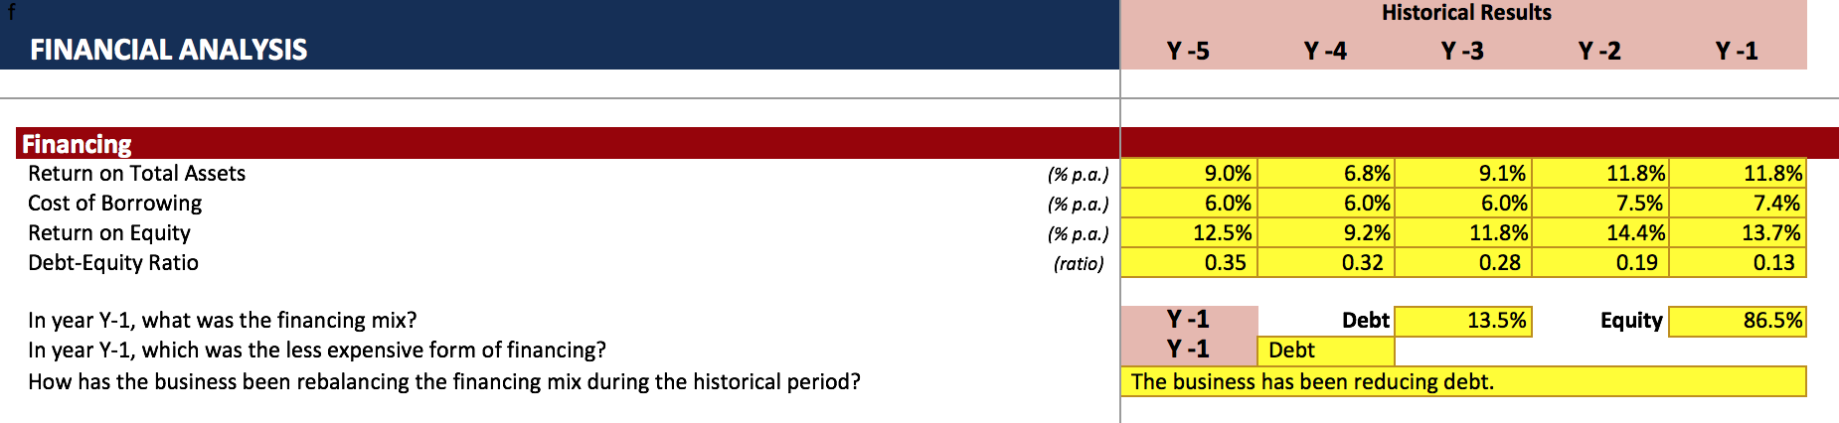

The table above shows the relevant figures of calculation, we can see that in the period of Y-1, ROA=11.8%, COB=7.4%, ROE=13.7% and D/E=0.135, therefore, the financing mix in this period was consisted of 13.5% Debt and 86.5% Equity. Debt was a less expensive form in this case and the business has been reducing debt to rebalance the financing mix.

**b.** **Analyse and interpret the (i) Income Statement (ii) Balance Sheet (iii) Cash Flow Statement to answer the following key questions**

Year-over-year is a calculation that helps compare growth over the previous 12 months. It is a great statistic to use when you want to control the effects of volatility when comparing companies or economies.

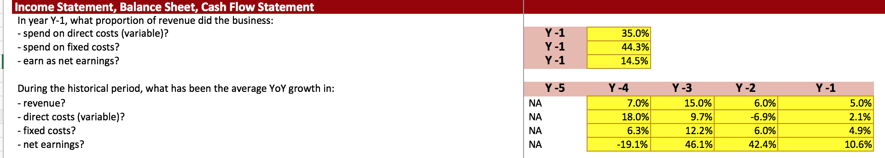

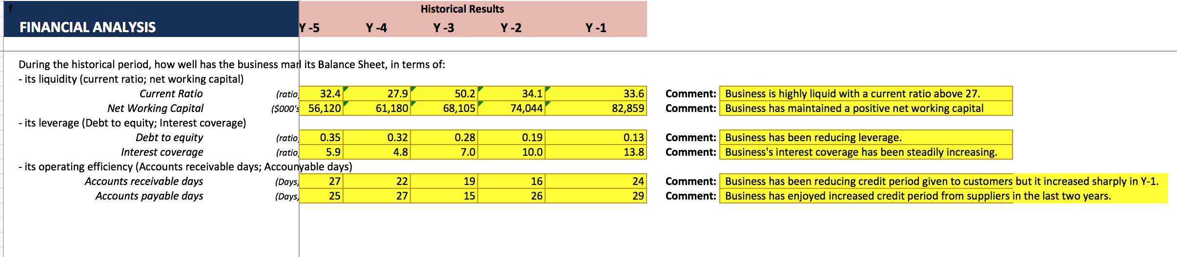

**2. In the “Historical & Forecasts” worksheet, use the provided assumptions to complete the Forecast Period section for**:

1. Income Statement

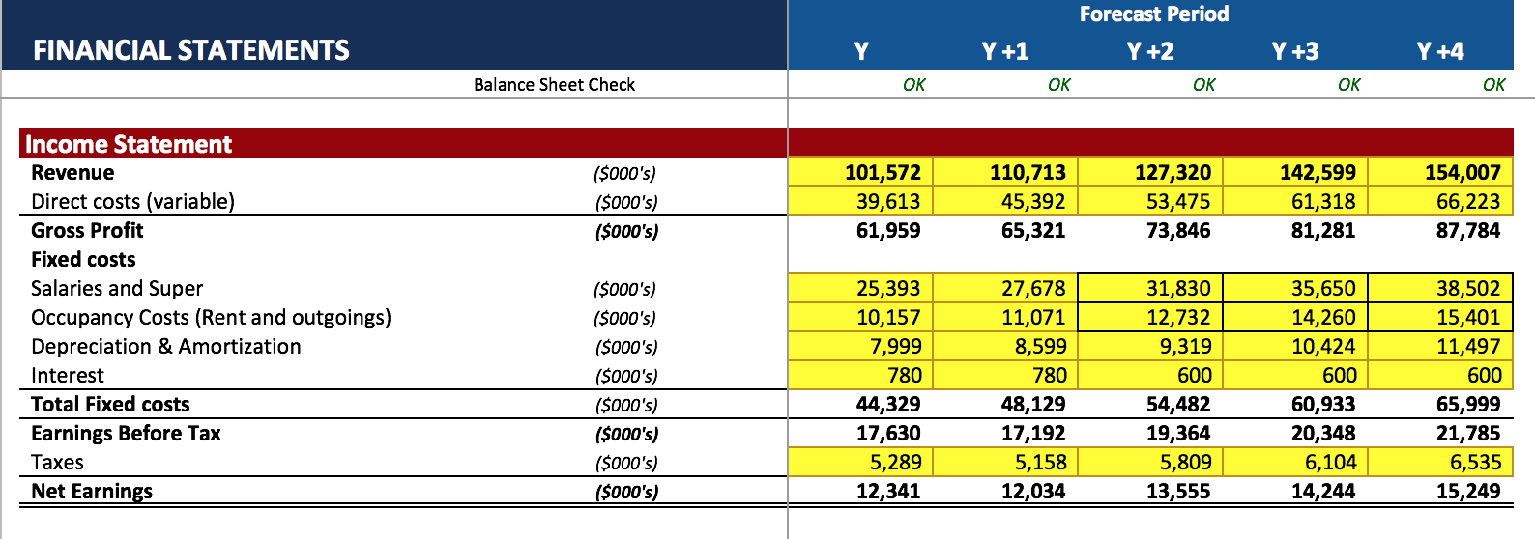

​

1. Balance Sheet

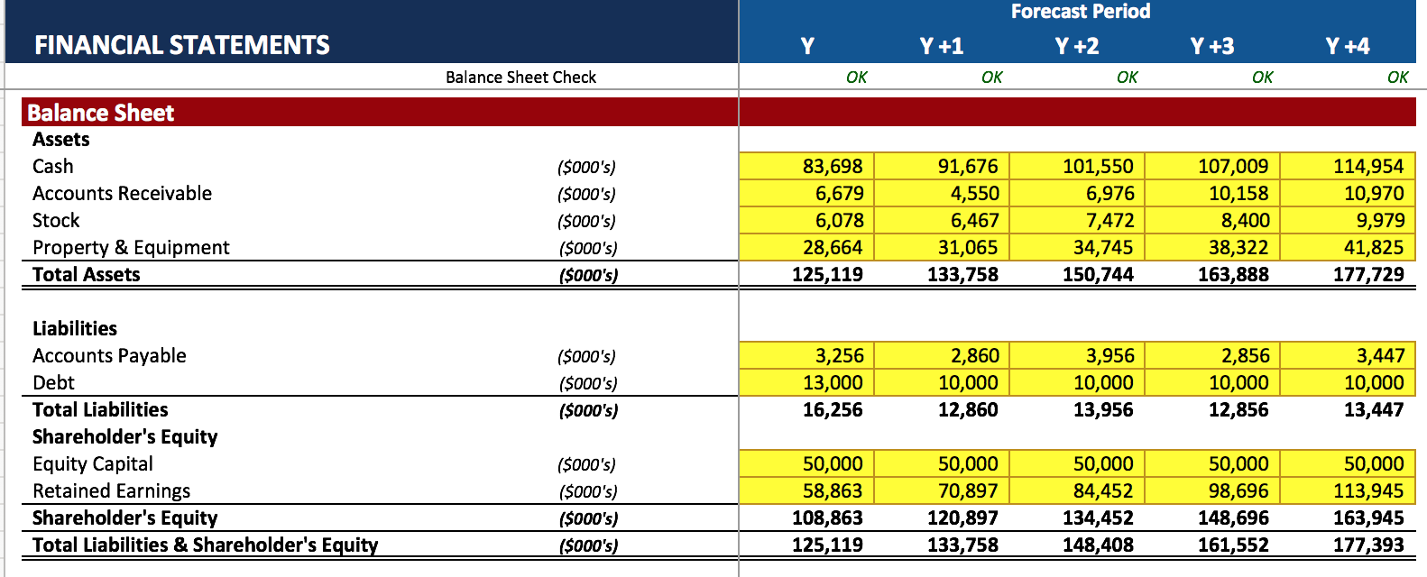

1. Cash Flow Statement

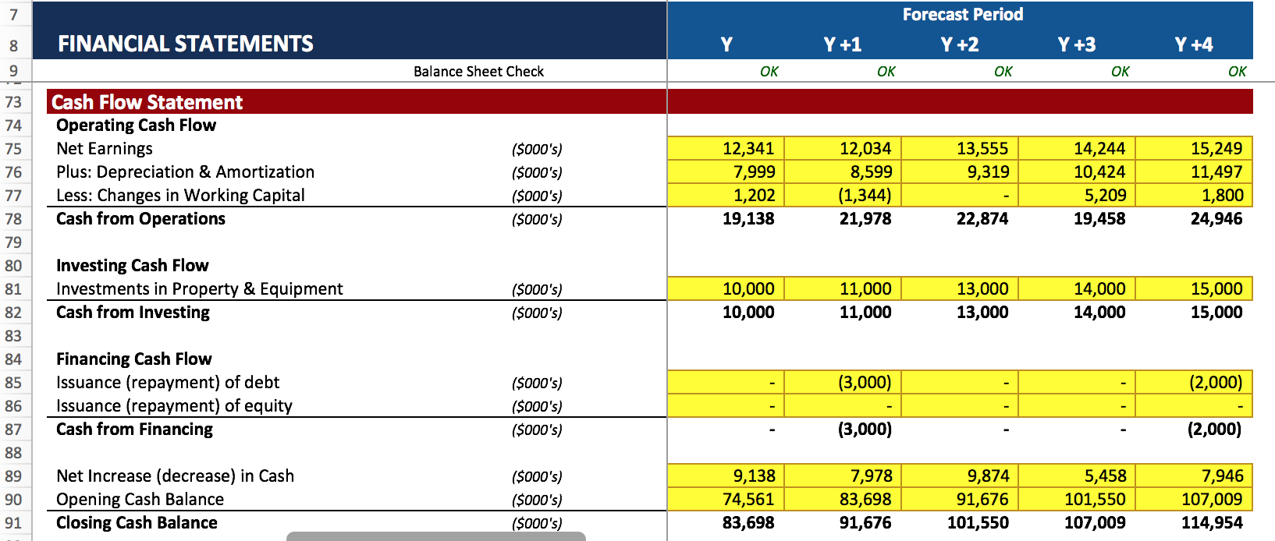

1. Business Systems

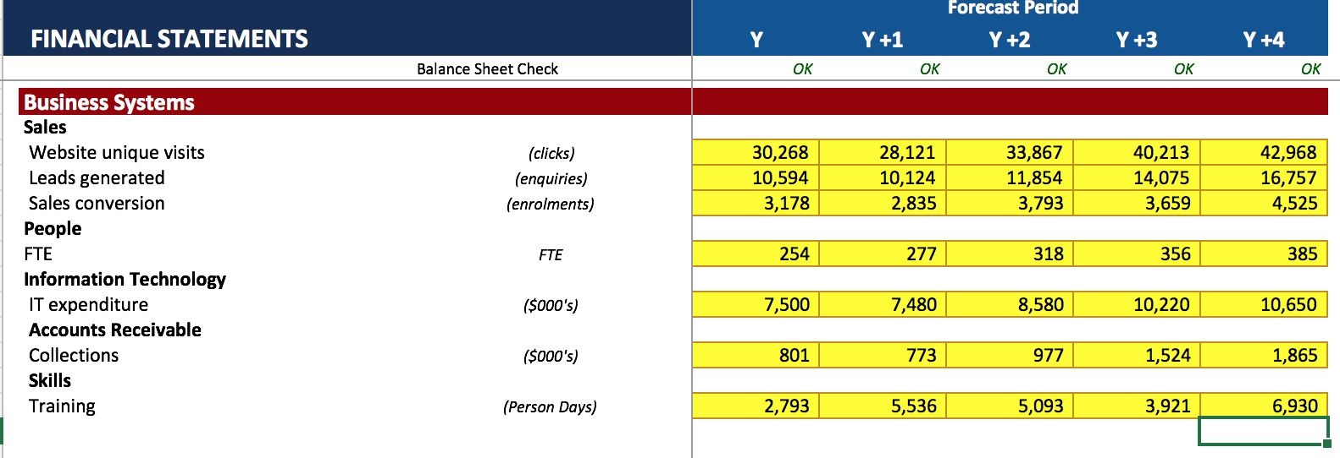

**3. In the “Historical & Forecasts” worksheet, use the provided budget constraints to complete the Budget Forecast section for:**

**Budget Forecast**

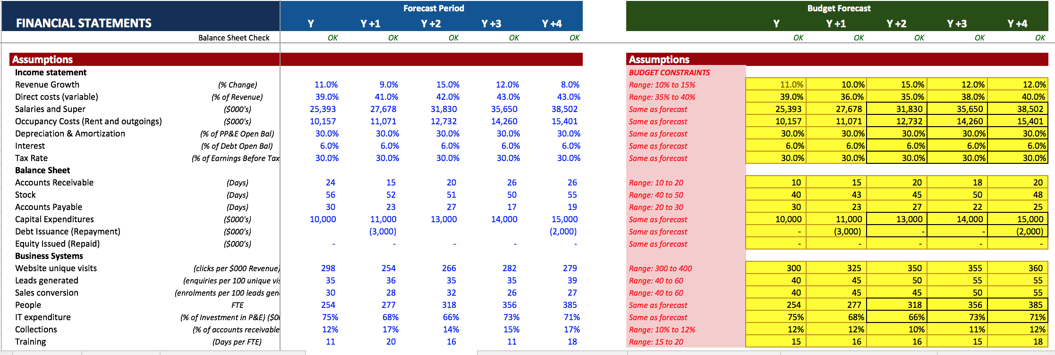

1. **Income Statement**

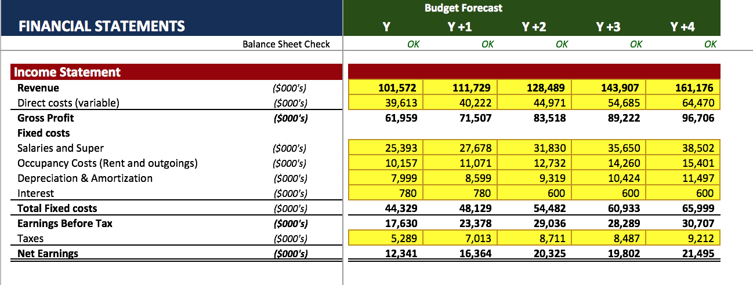

1. **Balance Sheet**

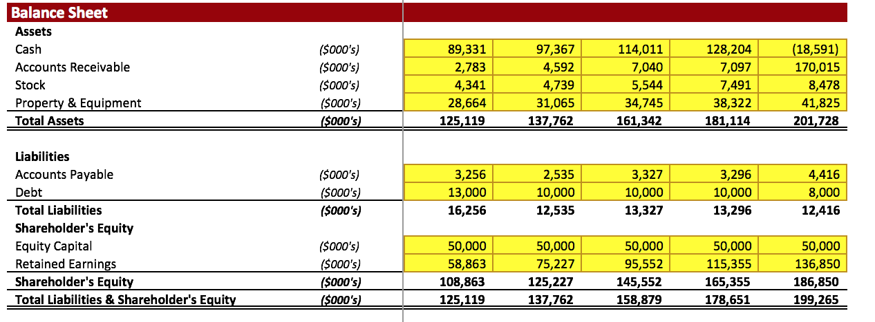

1. Cash Flow Statement

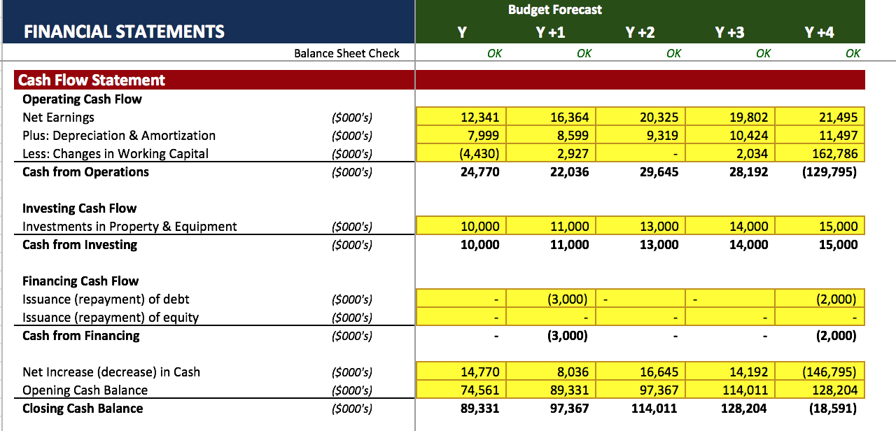

1. Business Systems

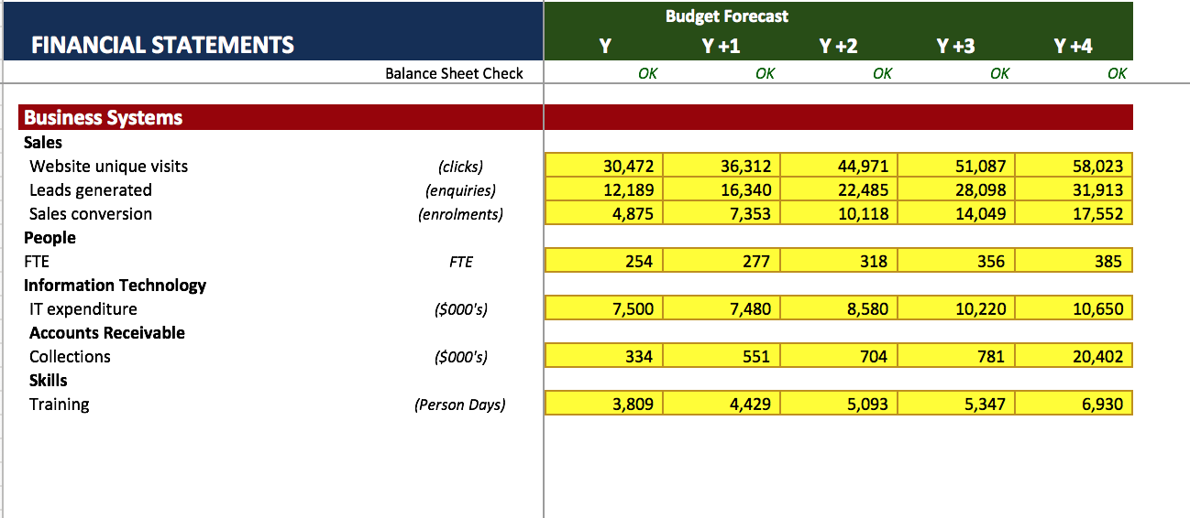

**4. In the “Recommendations” worksheet prepare your budget expenditure recommendations.**

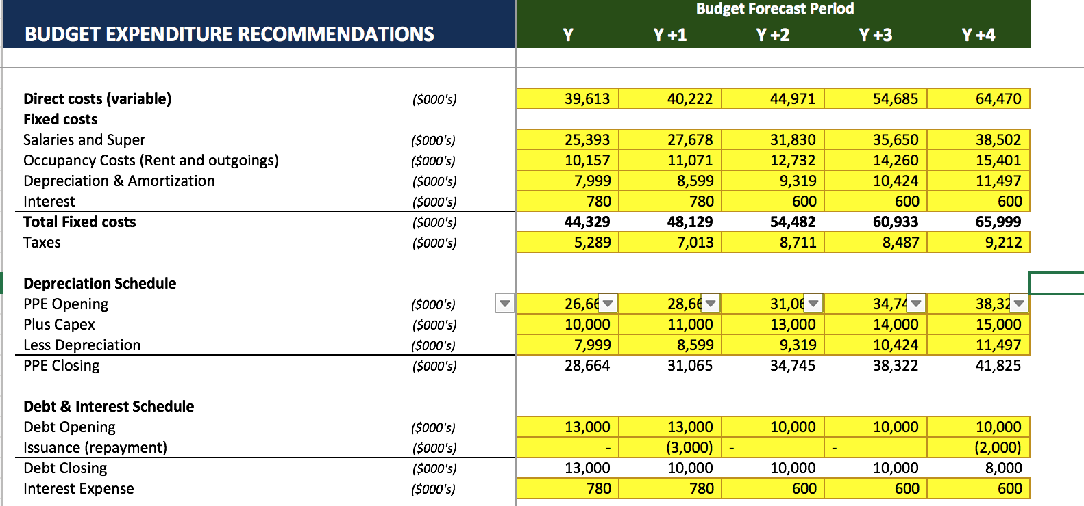

**5. In the “Financial Decisions” worksheet, analyse and evaluate the effects of the following financial decisions on the ability of Apex Learning Institute to meet the planned budget expenditure for Total Fixed Costs, in the Budget Forecast period.**

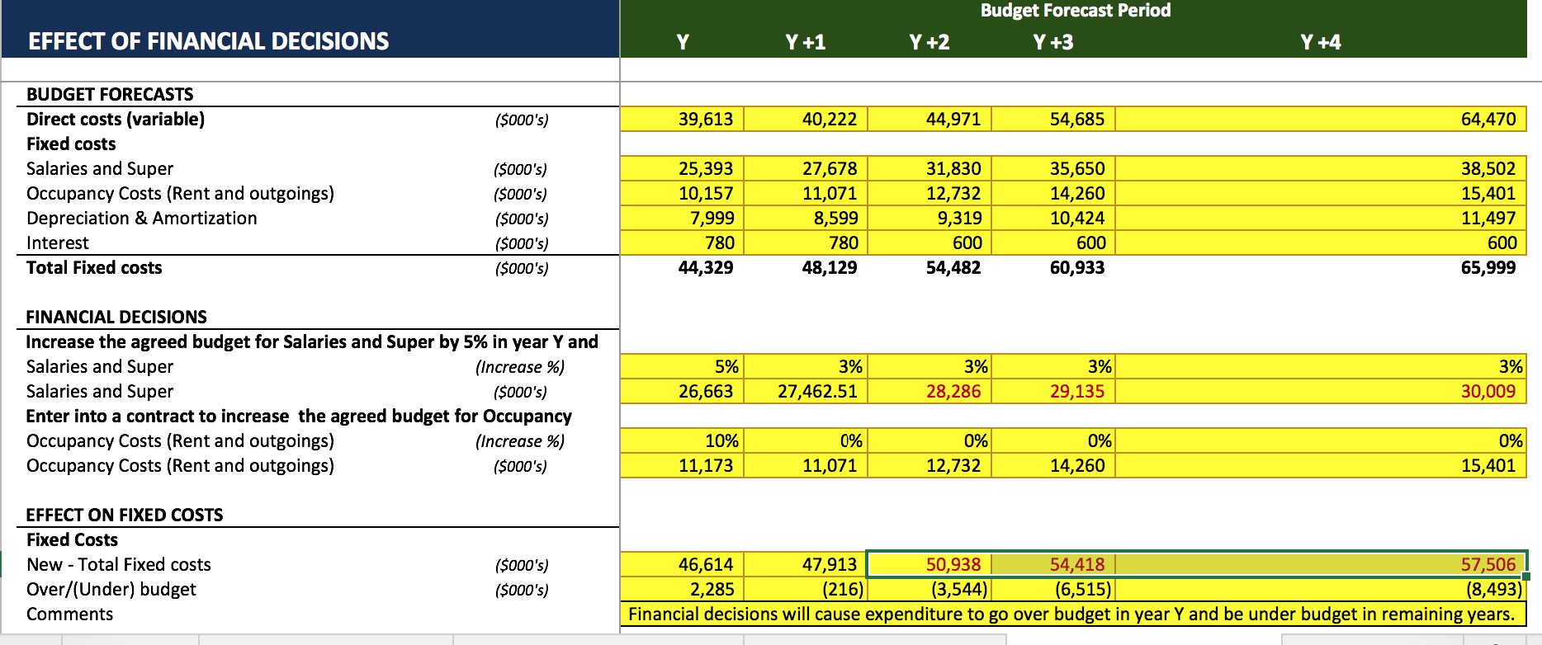

## Part E – Prepare performance monitoring template and risk management plan

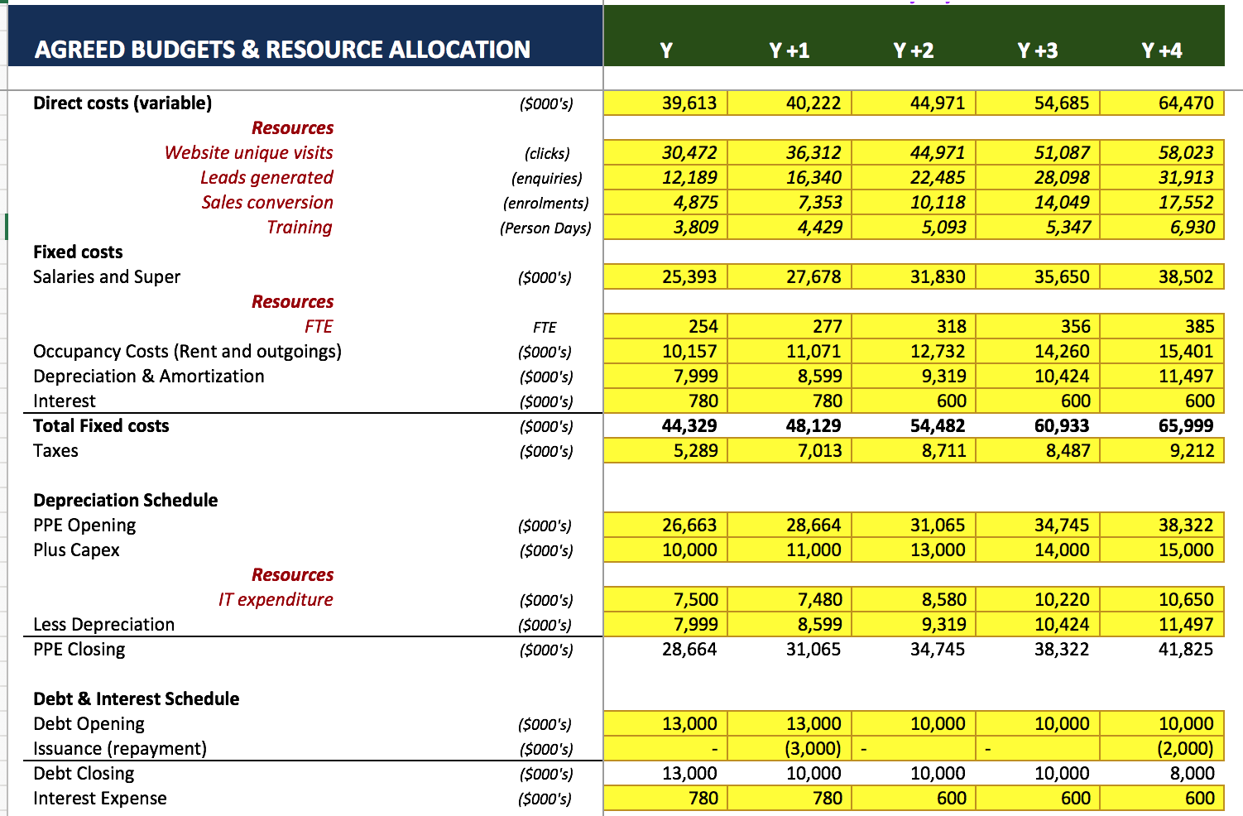

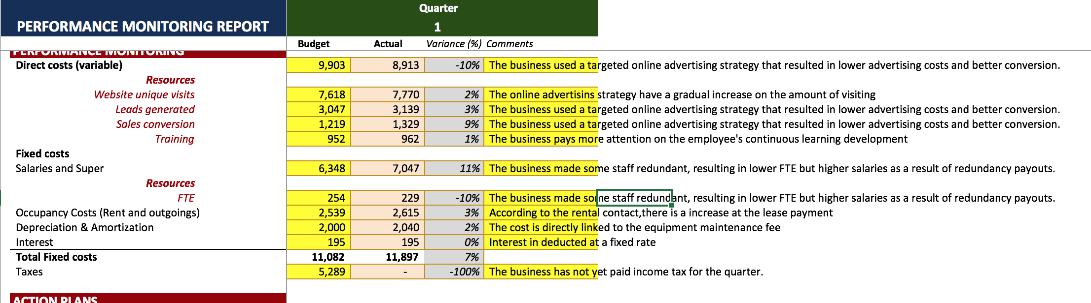

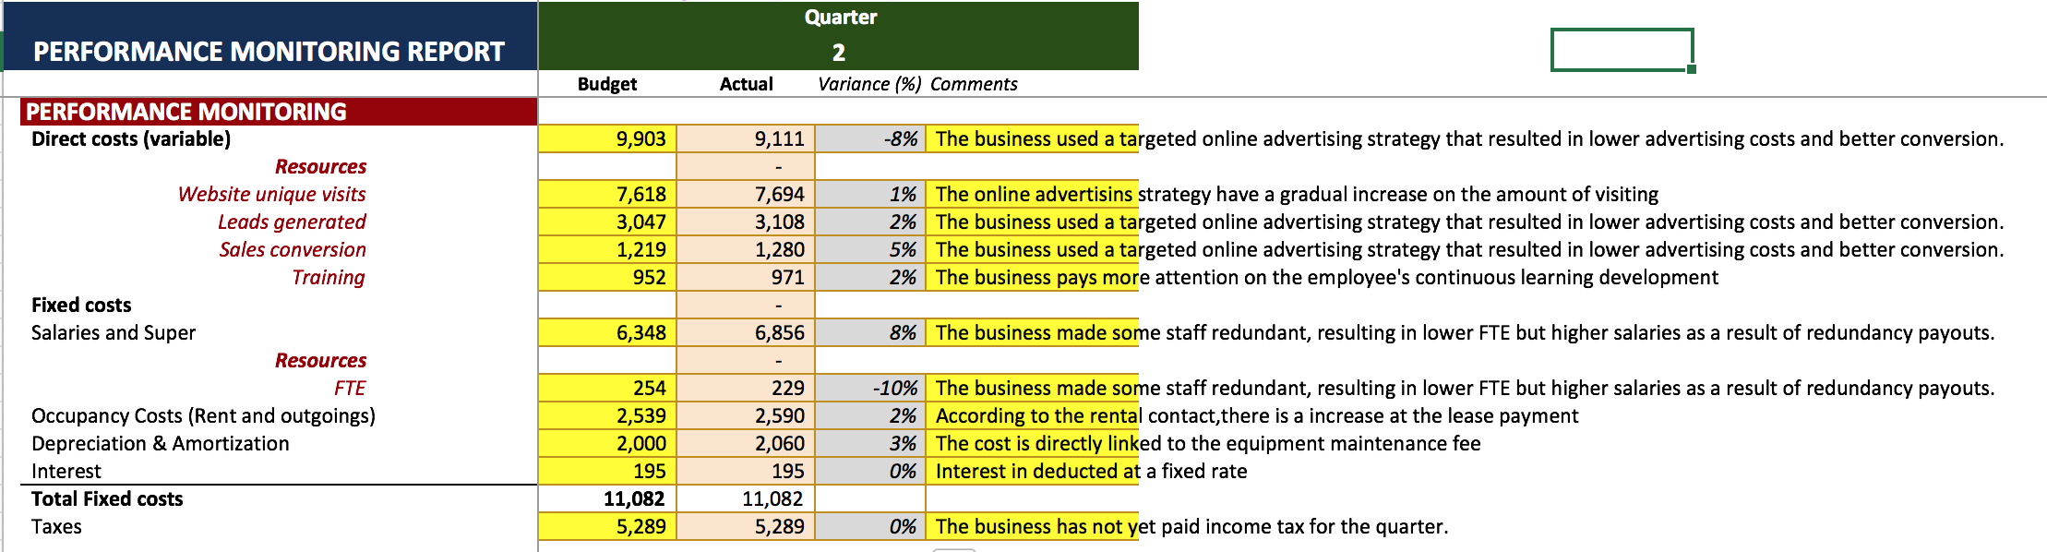

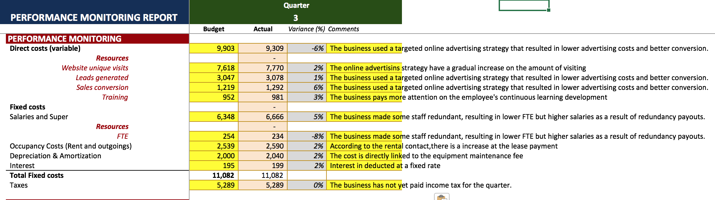

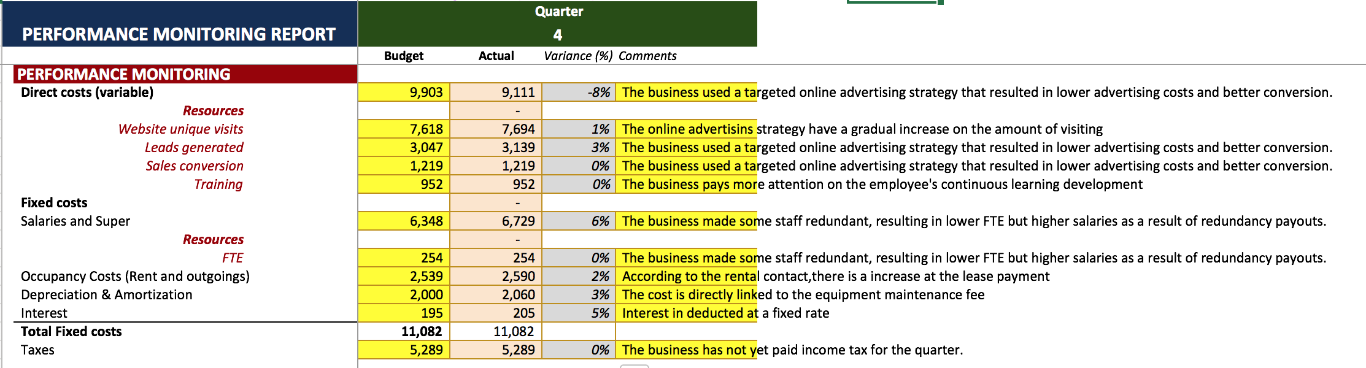

**(b) Action Plan**



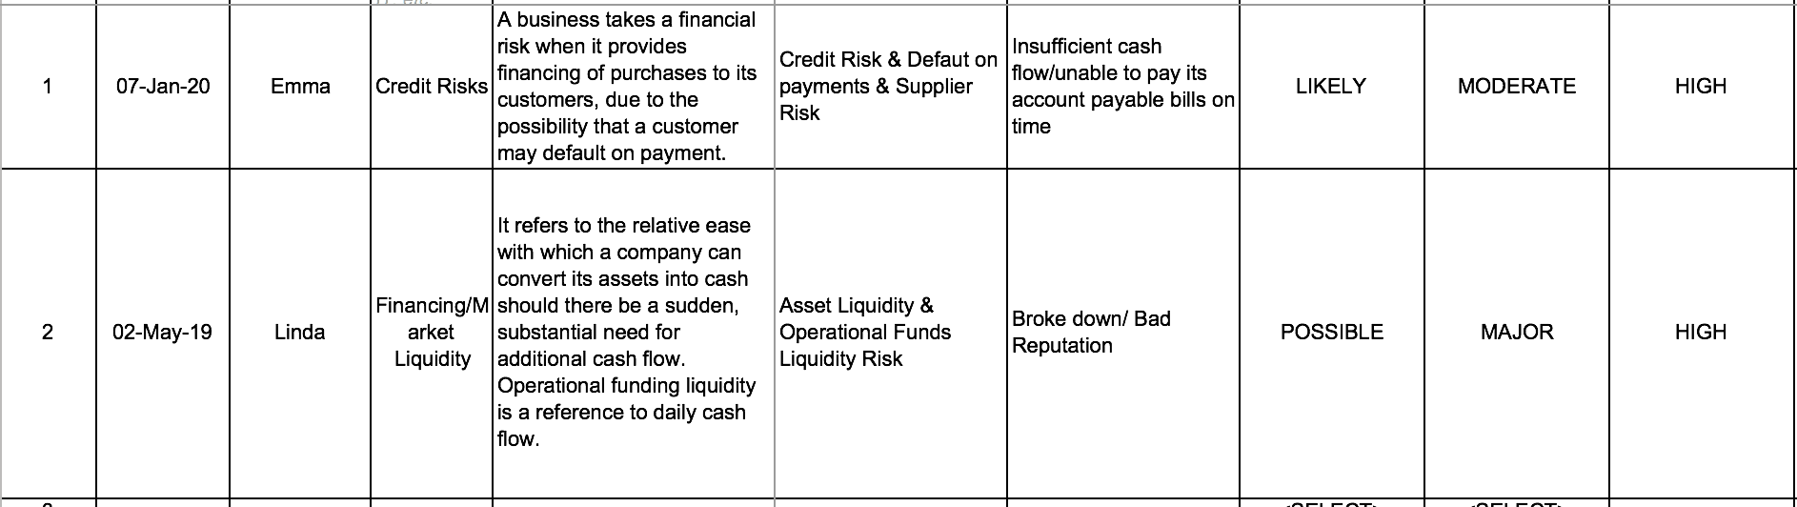



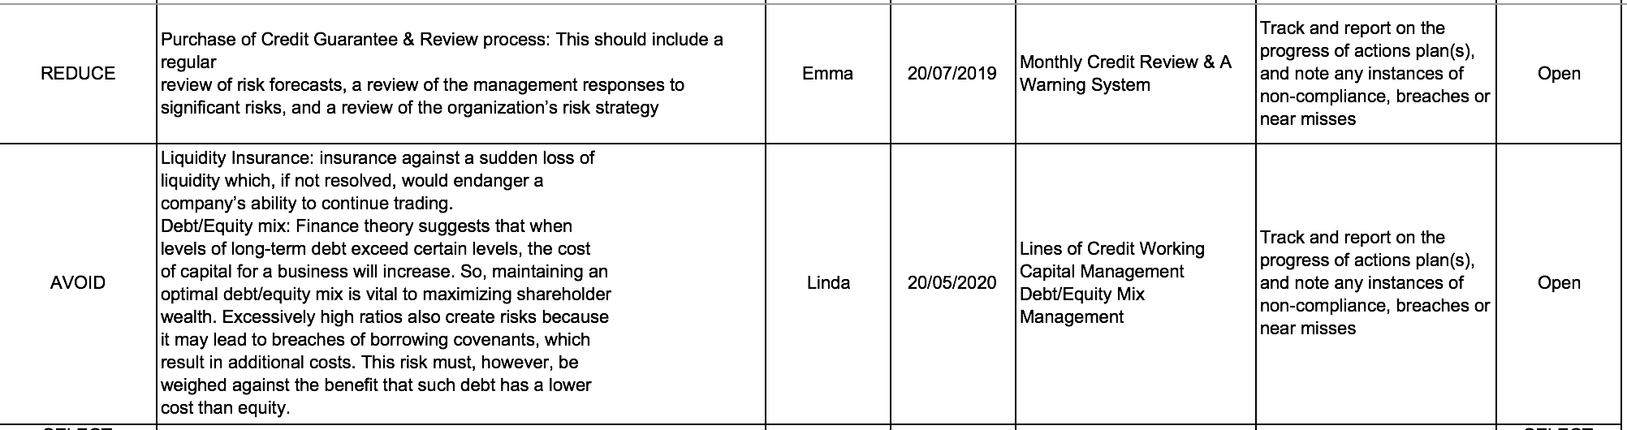

**Part F**



After comparing the actual performance with the budgets in Q1, year Y, the following items have been identified that vary significantly from the relevant budgets:

* Sales conversion
* Salaries and super

To increase the Sales Conversion:

* Add a pop-up to the site

According to a [study by Sumo](https://sumo.com/stories/pop-up-statistics), the average conversion rate for all pop-ups is 3.09 percent. However, if you do it the right way, you can reach the top 10 percent of pop-ups which average a 9.28 percent conversion rate.

* Add testimonials, reviews and logos

No one wants to be the first person to use a product or service. So, you can put their mind at ease by providing testimonials and/or reviews from past customers.

* Remove distractions

There’s nothing worse than visiting a website that pulls you in too many directions.  The landing page should be clear, concise, and easy to navigate. If it’s not essential, don’t include it. Stick with what your visitors need to know and nothing else.

To decrease Salaries and Super:

* Review levels of compensation

Salaries and wages tend to move one way: upwardly, even though markets and financial conditions change. Review your pay schedules to be sure they are in line with current trends, not the result of history. If current employees are earning more than what would be paid for their jobs today, delay or make only token raises until such time that your payroll comes in line with current trends.

* Reduce employee turnover

If you have significant turnover, you have excess costs in your operation due to the fees and salaries of those people engaged in the recruitment, selection, employment, and training of new employees. The indirect and invisible costs are poor quality, longer production times, greater waste, greater oversight, and even fraud, since your employees view their time with you as temporary. Maintaining a stable employee core is the key to effective cost-cutting.

* Cross-Train employees

Specialists – workers with a unique skill or license – generally command premium pay in the marketplace. But they also inhibit your ability to make changes in your operation if you are dependent upon their skills. A workforce trained to perform a variety of operations will enable you to make changes, including layoffs, without affecting your ability to deliver products or services to your customers.

* Eliminate Redundancy between departments

As companies grow, they often evolve into a group of independent departments, effectively eliminating inter-departmental communications and flow. In many cases, the same task is repeated in several departments. Periodically review your processes – handling orders, collecting funds, directing installations – to ensure minimal redundancy between separate functions.

**Revised Budget Priorities:**

How to manage the relevant costs to solve the problem of low sales conversion:

* Do A/B testing

In conversion optimization, the core part is testing. Experimentation is the best way to mitigate risk in decision making while allowing your creative teams room for innovation and exploration of new opportunities.

* Create a compelling and clear value proposition

The potential a conversion rate is determined by the [value proposition](https://cxl.com/value-proposition-examples-how-to-create/), making it the most important conversion factor. Crafting a value proposition requires substantial reflection on what is unique about your company and your products and services. Having a powerful value proposition is not enough; it must be communicated effectively to achieve optimal results. You need to refine your value proposition until you can articulate it in a single, instantly credible sentence.

* Set up a sales funnel

Sometimes what kills your conversions is that you’re asking for the sale (signup, whatever) too fast. People might be “just browsing,” not be psychologically ready or not in a hurry to buy right now. **The more expensive and/or complicated the product, the more time people need before they’re ready to commit.**For software products sometimes offering a demo or a free trial instead of asking for a signup or purchase can bring significant improvement in conversions. But in many cases we need to just slow down and build a sales funnel to build trust, develop relationship and prove our expertise.

How to manage the relevant costs to solve the problem of high labor cost:

* Review the compensation and benefits structure

Obtain up-to-date wage and salary information. Compare your budget for wages and salaries to the overall cost of running the business and projected sales to ensure there are no other alternatives to cutting employees’ salaries.

* Develop an employee-focused communication plan

Before beginning calculating salary cuts, talk to employees about the company’s cash flow problems. Draft an explanation for the highest ranking member of your organization’s leadership team to share with employees. Assure employees that the first priority is job security. Convey a very nonthreatening message that during an economic downturn, a lower salary is better than no salary at all.

* Negotiation

Negotiate carefully with employees who volunteer to take a pay cut or employees who offer to take a furlough instead of a pay cut. Well-paid employees may volunteer to take a pay cut, which can be extremely helpful. Refrain from agreeing to furloughs because, if they are handled improperly, a furlough can become problematic concerning a salaried employees' exempt status.